Exp-3: Generative Adversarial Network

AIM:
To implement a Generative Adversarial Network (GAN) to generate synthetic images using the MNIST dataset.

DATASET:
MNIST Handwritten Digits Dataset

PROCEDURE:
Step 1: Import Libraries import torch import torch.nn as nn
import torchvision import torchvision.transforms as transforms import matplotlib.pyplot as plt

Step 2: Load Dataset
transform = transforms.Compose([ transforms.ToTensor(), transforms.Normalize((0.5,), (0.5,))]) dataset = torchvision.datasets.MNIST(root='./data', download=True, transform=transform) dataloader = torch.utils.data.DataLoader(dataset, batch_size=64, shuffle=True)

Step 3: Define Generator

class Generator(nn.Module): def init(self): super(Generator, self).init()
AD23633 231501020

self.model = nn.Sequential( nn.Linear(100, 256), nn.ReLU(), nn.Linear(256, 512), nn.ReLU(), nn.Linear(512, 784), nn.Tanh() ) def forward(self, x):
return self.model(x)
Step 4: Define Discriminator

class Discriminator(nn.Module): def init(self): super(Discriminator, self).init()
self.model = nn.Sequential( nn.Linear(784, 512), nn.LeakyReLU(0.2), nn.Linear(512, 256), nn.LeakyReLU(0.2), nn.Linear(256, 1), nn.Sigmoid() ) def forward(self, x):
return self.model(x)
Step 5: Initialize Models generator = Generator() discriminator = Discriminator()

Step 6: Loss and Optimizer criterion = nn.BCELoss() g_optimizer = torch.optim.Adam(generator.parameters(), lr=0.0002) d_optimizer = torch.optim.Adam(discriminator.parameters(), lr=0.0002)

Step 7: Training GAN epochs = 10 for epoch in range(epochs): for images, _ in dataloader:
images = images.view(-1, 784)
real_labels = torch.ones(images.size(0), 1) fake_labels = torch.zeros(images.size(0), 1)
outputs = discriminator(images)
AD23633 231501020

d_loss_real =criterion(outputs, real_labels)  noise = torch.randn(images.size(0), 100) fake_images = generator(noise)  outputs = discriminator(fake_images.detach()) d_loss_fake = criterion(outputs, fake_labels)  d_loss = d_loss_real + d_loss_fake d_optimizer.zero_grad() d_loss.backward() d_optimizer.step() outputs = discriminator(fake_images) g_loss = criterion(outputs, real_labels) g_optimizer.zero_grad() g_loss.backward() g_optimizer.step() print(f"Epoch [{epoch+1}/{epochs}] | D Loss: {d_loss.item()} | G Loss: {g_loss.item()}")  Step 8: Generate Images noise = torch.randn(16, 100)  generated_images = generator(noise).detach() generated_images = generated_images.view(-1, 28, 28) fig, axes = plt.subplots(4, 4, figsize=(5,5)) for i, ax in enumerate(axes.flat):  ax.imshow(generated_images[i], cmap='gray') ax.axis('off') plt.show()  AD23633 | 231501020
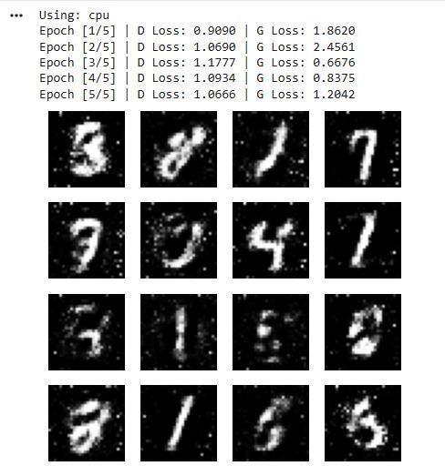
AD23633

231501020

OUTPUT:

RESULT:

The

GAN

successfully

learns

to

generate

handwritten

digit

images

similar

to

MNIST.

Initially,

outputs

are
noisy,

but

improve

with

training

as

the

generator

and

discriminator

compete.

